Shabbos Stories for
chanukah 5777
Volume 8, Issue 15 25 Kislev 5777/ December 25, 2016
Printed L’illuy nishmas Nechama bas R’ Noach, a”h

For a free subscription, please forward your request to keren18@juno.com

The Miracle of
Bubbie's Menorah
By Eli Hecht

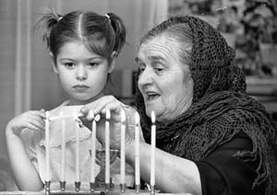

My sweet grandmother is a small woman, barely five feet tall. Her two feet tall candelabra was more than just a candle-holder. It was a family symbol, a magnet that brought us all together.
On Shabbat evenings Bubbie would don a special Shabbat kerchief. With great fanfare she would light each candle. When she finished lighting the last candle, she stood in front of the candelabra and closed her eyes. Tears ran down her cheeks. She prayed for her husband, her married children and her grandchildren. She spoke in Yiddish, "Her mein tier tata, hiet oif mein man, kinder un di eyniklach...." (Dearest Father in Heaven, watch and protect my husband, children and grandchildren. May it be your will that they grow up to be good people who are loyal to our religion. Please grant my dear husband a livelihood and patience. Watch over us all.)
We all stood by the Shabbat table in awe. Bubbie looked like a queen speaking to the King of Kings, the Almighty G-d. When she finished her prayer, we began our Shabbat.
As our family grew, Bubbie spent more time with her candles. By the time she reached her 94th birthday, she had many married grandchildren, who also had children of their own. There were five generations in Bubbie's family. When lighting the candles, Bubbie prayed for each family member.
Her candelabra was made of solid silver with a heavy silver base. All year-round it had three branches of two candlesticks. In the middle was a stem for another candle. The traditional custom for Shabbat eve is to light one candle each for the father, mother and children. As each child is born, another candle is added to the Shabbat lighting. Throughout the year Bubbie's candelabra was fitted for five candles.
During the week of Chanukah, she added another branch of two candlesticks each, making a total of nine candles. The candelabra was built in such a way that the candle holders could be removed and oil cups could be inserted for the special lighting on Chanukah. Our Shabbat candelabra became a Menorah.
During the week of Chanukah she gave her prized candelabra to my grandfather to light candles for the holiday. Chanukah was our happiest time. All the children, grandchildren and great-grandchildren came to Bubbie and Zaydie to receive Chanukah gelt and join in the Menorah lighting.
Imagine the two-foot menorah with nine candles shining in all its glory. Zaydie stood proudly like a Kohain, the high priest in the temple, when he lit the menorah.
When Zaydie died, Bubbie would spend her winters in Miami Beach. She took her candelabra with her. Every Shabbats Bubbie would shine the silver candelabra and pray, "May my mazel (luck) always shine!"
All this came to an end when someone stole her menorah. Bubbie was livid. Her small body shook like a willow in the storm as she spoke about her most prized possession, her candelabra. How could anyone steal it? Her only concern was how she would light her candles.
She believed the menorah would return. "I have prayed that the menorah would protect us, and I'm sure that the menorah has done just that. Now I pray that the menorah protect itself and be returned to me."
With silent determination she prayed and prayed. The family did not know what to do. Unexpectedly a childhood friend from Austria, Bubbie's birthplace, once visited us and announced, "I never saw another menorah like yours until today. Surprisingly I saw a replica of your menorah, in the window of a gift store."
We were dumbfounded. Could it be that our guest had seen the stolen menorah? Bubbie jumped back and said, "Let's get my menorah back! It soon will be Chanukah and I need the menorah back."
Bubbie, my parents, Bubbie's girlfriend, and a policeman made their way to the gift shop. With a gleam in her eyes and a shout of joy Bubbie pointed to her menorah and said to it, "Yes, you have done well. You have protected us and now you have protected yourself. Come back home with me."
Before anyone could say anything, Bubbie grabbed the menorah off the shelf and held it close to her heart. Nobody could stop her. Neighbors, Jewish and non-Jewish, joined Bubbie in her triumphant walk home. The closer she neared home, more and more people joined her. Bubbie, dressed in the European manner, with her slight frame carrying a menorah almost as big as her, followed by a procession of excited family and friends, was a sight to see. It truly was a grand Chanukah parade.
The menorah was given a special cleaning, and that Chanukah was the brightest in Bubbie's home. Who says that miracles don't happen anymore?

Reprinted from the Chanukah website of Chabad.Org

MODI’IN — FORTRESS OF THE HASMONEANS

The modern city of Modi’in founded in 1994, and the religious community of Modi’in Ilit (Kiryat Sefer) nearby, recall one of the miracles of Chanuka now being celebrated by Jews throughout the world. As we say in the special prayer of that day, “It was in the days of Matityahu, son of Yochanan the Kohen Gadol, the Hasmonean, and his sons” that the miracle of “the mighty and numerous Greek forces” bent on forcing assimilation were overcome by “the weak and few”. Mount Modi’in was the place where the Hasmoneans rallied their outnumbered forces and with the help of Heaven achieved victory over their oppressors. (OHRNET)

Chanukah – Lighting Left
By Rabbi Yirmiyahu Ullman

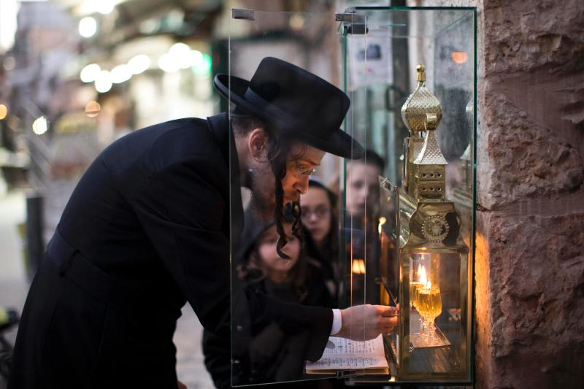
A man lighting a Chanukah Menorah in Yerushalayim

From: Chava

Dear Rabbi, It seems to me that the right side is usually given precedence in performing mitzvot. Why is the Chanukah menorah lit on the left side of the doorway?

Dear Chava, Many people nowadays light inside the house either on a table or near the window. But it is correct that according to the original halacha, and as still practiced by many today, the ideal location to light the Chanukah menorah is on the left side of the main, outer doorway into the house.
One reason that’s given in the sources is in order that a person will be encompassed by mitzvot — by the mezuzah, whose place is fixed on the right, and the menorah, which is therefore placed on the left. In this way, a person’s goings out and comings in are illuminated by the spiritual and physical light of the mezuzah and the menorah.
In addition, the verse states, “There is length of days in its right hand; in its left there are wealth and honor.” “Length of days” refers to the World-to-Come, which was given to Israel. “Wealth and honor” belonged to Yavan (ancient Greece), the descendent of Yefet. But when the Greeks tuned to evil, Israel merited their portion as well. Hence we have the mezuzah, which mentions length of days, on the right; and we light the menorah to symbolize our victory over Greece on the left, expressing our hope to receive their wealth and honor for the purpose of serving G-d.
Another idea is that since the doorway serves for entry as well as departure, while the menorah is on the left of the doorway going in, it illuminates the right side going out. That is to say, this lamp sheds light upon us even when we are “outside”, in exile among the nations of the world. And even now, while the Temple is not built, the light of the Chanukah menorah illuminates our path in exile.
In a similar light, the original altar was consecrated on the 25th of Kislev, the same day on which Chanukah was later instituted. The mitzvah of making a sanctuary for G-d in which He may dwell in our midst is thereby timeless, and every Jew is obliged to yearn daily for the rebuilding of the Temple.
One way we do this is by lighting the Chanukah menorah in memory of the miracle that occurred during that rededication of the Temple. And we place it facing outward on the right — like a person on vigil waiting at the door in anticipation of a long-expected wayfarer’s return. May we merit the arrival of Mashiach and the restoration of the Final Temple speedily in our days, Amen!

Reprinted from the 5776 Chanukah email of OHRNET, the Ohr Somayach Torah Magazine of the Internet.
Chanukah, 1942
By Carola Schiff

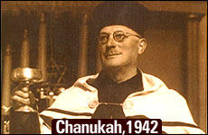

Spreading the light in Nazi-occupied France.

My father, Reb Meir Shlomo Sommer, Monsieur Sommer as he was called in France, was a man of uncompromising faith, conviction and courage. He was the principal of a Jewish Day school in Hamburg/Altona, Germany until Kristallnacht, when the Nazis closed the school. In July 1939, my father and mother were able to flee to France on a two week tourist visa to escape the Nazi reign of terror. In France both my parents were interned, separately, in various detention and labor camps. By Divine miracle, they were both released and reunited in October 1940.
Since they were Jewish refugees from Germany, they were considered a threat to France and were forced to go into hiding in the outskirts of Perigueux, a small town in southwestern France.
In 1942, at the height of the Nazi reign of terror, there were constant "Raffles" – Jews would be summarily rounded up and sent to horrible detention camps and from there to the infamous death camps of Eastern Europe. Curfew times were enforced and no one was allowed on the streets at night. It was a constant struggle to find hiding places to evade the Nazis and their French collaborators.
"From a population of about 330,000 at the end of 1940, nearly 80,000 Jews had been deported or murdered in France. They represented more than 24 percent of the Jewish community." (The Holocaust, The French, and the Jews, Susan Zuccoti p.207).
During their internment and in hiding, my parents clung to their faith with tenacity. Against all odds, my father maintained his strong Torah principles, never compromising on Kashrus, Shabbos or Jewish holidays. He was a man of strength and kindness. He was filled with love for his fellow Jew, and always tried to help others in need. He would regularly ignore the war-imposed curfew, and at the risk of his life, braved the terror of the Nazis in order to teach Torah to Jewish children in hiding.
After the war, my father was the spiritual leader in Vichy, France. Shortly after his untimely death in 1956, we received the following condolence card highlighting how my father managed to spread the light of Chanukah during the darkest time in Nazi-occupied France:

Chanukah 1942
1942 in Perigueux, France, a few men hurried into a rundown wooden barrack. Each opened the door carefully looking around to make sure they weren’t being followed. They then went into a hidden backroom. This room served as the makeshift Shul for those brave enough to venture out. The "shul" barely scraped together a minyan of men to pray.
They davened Maariv quickly, their hearts rapidly beating with the knowledge that at any moment the Nazis could storm in and arrest everyone. One man lit the menorah as the others ran to grab their coats and get home as fast as possible.
Suddenly, a man in the back of the room stood up and in a deep, warm voice started to sing “Maoz Tzur.” The men were frightened and aghast. Someone might hear; it was too dangerous! Soon another man joined in singing, then another and another, until everyone was tearfully and courageously singing with joy. For the moment, gone were the fears of the Nazis. For a few moments, Chanukah was there in all its glory, as in days of Judah the Maccabbe, a few brave men stood proud, their faith prevailing over the evil surrounding them.
The man who stood to sing was my father, Reb Meir Shlomo Sommer known to all as Monsieur Sommer, of blessed memory. My father had never told anyone of us his Chanukah victory during those dark time, yet even after his death, this story continues to inspire light.

Reprinted from the Chanukah website of Aish.com
Sufganiyah – To Eat or Not to Eat, That is the Question!

Why Jelly Doughnuts Are
Eaten During Hanukkah
By Emelyn Rude

It's not just a matter of celebrating with foods cooked in oil

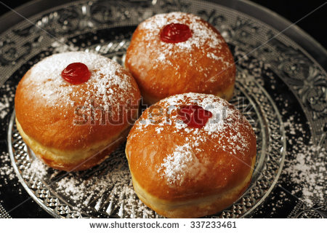

The Israeli version is the sufganiyah—the singular of sufganiyot—and it’s not only the L-rd’s consolation prize, but also a staple of annual Hanukkah celebrations. It’s said that the fried treats are a good fit for a holiday focused on oil, commemorating the miracle of one night of oillasting for eight. The most stereotypical sufganiyot, after all, are fried balls of yeast dough filled with strawberry jelly and dusted heavily with powdered sugar.
But jelly doughnuts weren’t a part of a typical diet at the time the Hanukkah story would have taken place, and the miraculous oil isn’t the whole story behind why they’re eaten on the holiday.
The word sufganiyot can be traced back to the Greek word sufan, meaning “spongy” or “fried,” as can the Arabic word for a smaller, deep-fried doughnut named sfenj. This could perhaps be where these treats got their name; similar fried balls of dough have been eaten to commemorate Hanukkah for centuries by Jews in North Africa.
But these Moroccan and Algerian treats didn’t have the modern sufganiyot’s characteristic jelly filling, which is where migrants from Central Europe came in. The first fried pastries in European history typically contained savory fillings, like meat or mushrooms. But the establishment of colonies in the Caribbean in the 16th century brought cheap, slave-produced sugar to the continent and led to a renaissance in fruit preserves and from that a renaissance in sweet stuffed pastries.
The first known recipe for a jelly doughnut, according to historian Gil Marks, can be found in the 1532 German cookbook Kuchenmeisterei, which translates to “Mastery of the Kitchen” and is remembered by history for being one of the first cookbooks run off of Gutenberg’s famed printing press. The treat was made by packing jam between two round slices of bread and deep-frying the whole thing in lard.
From its Germanic origins, the dessert quickly conquered most of Europe. It became krapfen to the Austrians, the famous Berliners to the Germans and paczki to the Polish. Substituting schmaltz or goose fat for the decidedly un-Kosher lard in their fryers, the Jewish peoples of these regions also enjoyed the dessert, particularly Polish Jews, who called them ponchiks and began eating them regularly on Hanukkah. When these groups migrated to Israel in the early twentieth century, fleeing the harsh anti-Semitism of Europe, they brought their delicious jelly-filled doughnuts with them, where they mingled with the North African fried-dough tradition.
But it would take more than just the mingling of Jewish cultures to make the sufganiyot the powerful symbol of Israeli Hannukah it is today. Credit must be given to the Israeli Histradut. Founded in 1920 in what was then British-mandated Palestine, the national labor group’s aim was to organize the economic activities of the Jewish workers in the region. Founded on Russian socialist principles, full employment was amongst its aims, as was the integration of the new Jewish immigrants making their ways to the country’s shores.
The latke, the classic fried potato pancake that was already associated with Hanukkah celebrations, is a dish that can easily be made at home. A perfectly filled and fried sufganiyot is much more difficult. Even some of the most talented at-home cooks will agree that the treat tastes better when left up to the professionals. Which is exactly what the Histadrut wanted: a Hanukkah treat that involved professionals. As many important Jewish holidays are concentrated in autumn, the end of that season often brought a lull in work in Jewish quarters.
By pushing the sufganiyot as a symbol of the Festival of Lights, as opposed to the DIY-friendly latke, the Histradut could encourage the creation of more jobs for Jewish workers.
By all accounts, the Histadrut’s efforts to promote the jelly doughnut worked. In modern Israel, over 18 million sufganiyot are consumed in the weeks around the holiday, which averages out to over three doughnuts per citizen. More people enjoy the fried treat than fast on Yom Kippur, the holiest day in the Jewish calendar, and the Israeli Defense Forces purchase more than 50,000 of the doughnuts each day of the eight-day holiday to boost the morale of its troops.
Sufganiyot can now be found throughout the United States as well during Hanukkah, produced by Jewish and non-Jewish bakeries alike. After all, as people all over the world have been discovering for centuries, no one can say no to a truly delicious jelly doughnut.
Emelyn Rude is a food historian and the author of Tastes Like Chicken.

Reprinted from the December 7, 2015 edition of TIME Magazine

Israeli Health Minister Declares ‘Donuts – Out!’
By Times of Israel Staff

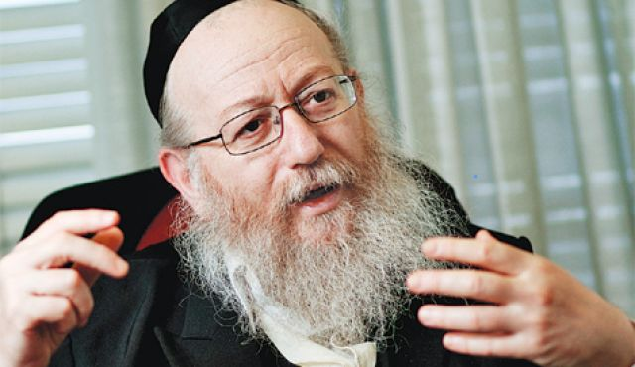
Health Minister Yaakov Litzman at a press conference at the Health Ministry in Jerusalem, on November 21, 2016. (Photo by Hadas Parush/Flash90)

[Rabbi] Yaakov Litzman says Israel must find alternative to sugary, oily Hanukkah treat, educate children to eat better. Health Minister Yaakov Litzman has urged Israelis to eat fewer sufganiyot, the oily jelly donuts traditionally eaten during Hanukkah — and in recent years in Israel, for weeks beforehand — as part of his crackdown on unhealthy food.
Litzman, of the ultra-Orthodox United Torah Judaism party, who in the past criticized the amounts of junk food eaten in Israel, and specifically called out fast-food giant McDonald’s, has now found another target, the Kikar Hashabat news site reported Sunday.
“When I said that we should cut down on McDonald’s, they thought I’d gone crazy,” Litzman told a healthy lifestyle forum. “If I would have said it today, I would have said, ‘Sufganiyot – out!'”
Litzman said that there are many healthy, alternative ways of celebrating the festival which should be encouraged.
“We can find alternatives and we don’t have to feed our children donuts which do not match health values and proper nutrition,” he said. “Obviously we can eat them, since they are part of our tradition, but there are better substitutes. I call on the public to avoid eating donuts which are full of oil.”
Litzman was speaking at a conference led by Professor Itamar Raz, head of the National Council for Diabetes.
In March, Litzman controversially attacked McDonald’s, saying that “there is no need to eat junk food, not in our country.”

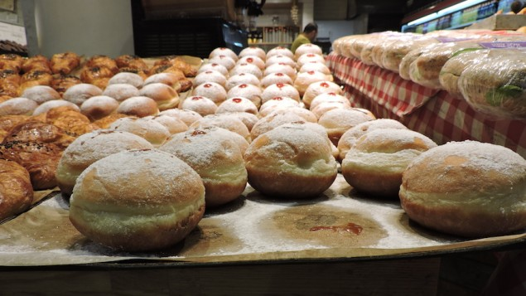
He urged parents and educators to teach children not to eat junk food and sweets and stressed that the Health Ministry would focus on “preventative” medicine this year to curb disease.
Now the minister may have bitten off more than he can chew in attacking these winter treats. Jelly donuts are very popular in Israel, where an array of flavors is featured at bakeries, supermarkets, coffee shops and restaurants beginning as early as October.
The Festival of Lights, which commemorates the Maccabean revolt against the Greeks, has long featured oily foods such as latkes and donuts in remembrance of the miracle of the temple oil, which lasted eight days instead of the expected one.
Jelly-filled donuts typically have around 375 calories per 100 grams. However, just days ago Burger King announced that, this Hanukkah, it will be offering a version of its Whopper burgers served on the traditional sufganiya.
The American fast food chain said the “Sufganiking” will be on sale at all Burger King chains in Israel starting on December 25, the first night of Hanukkah, until January 1st, and will cost NIS 14.90 ($4.00).

Reprinted from the December 12, 2016 edition of the Times of Israel.

The Story of Chanukah in Brief

REMEMBERING LIGHT
During the time of the 2nd Temple, the Holy Land was ruled by cruel Greeks. They robbed the Jews of their property, and set up idols in the Beit HaMikdash. No one could stand up against them, till Mattityahu and his sons rose up and drove them from the land. The Chanukah lights remind us of the great miracle that a small band of Jews defeated the mighty Greek armies.

FIGHTING FOR LIGHT
The Greeks were philosophers. They accepted the Torah as a book of wisdom, but not as something holy that connects us to Hashem. In the end, they made Torah learning illegal, and outlawed Mitzvot like Shabbat, Rosh Chodesh, Brit Milah, and the holiness of Jewish marriage. The Maccabeesrisked their lives to keep Torah alive! That’s why they won!

THE MIRACLE OF LIGHT
An even greater miracle than defeating the Greek armies was the miracle of the oil. The Greeks had made all the oil in the Beit HaMikdash impure. Miraculously, the Maccabees found one jar that had been overlooked. But it only had enough oil for one day. So great was their love of G-d, that they lit it anyway! Hashem made another miracle, and the oil burned for eight days! Everyone could see that the Shechinah dwelt with the Jews.

JOYOUS LIGHT!
With tremendous joy, the Jews cleansed the Beit HaMikdash and began to serve Hashem once again! Nowadays, we have to draw on that joy, because the darkness has grown very great! That's why we make Chanukah parties, with dreidels, latkes, and Chanukah gelt. Joy has the power to overcome any negative thing, and break any evil decree!

ADDING LIGHT!
Every day of Chanukah we add another candle till all eight candles of the Menorah are ablaze. By adding a candle every night for 8 days, we charge ourselves up with light, so that we will constantly be adding in Torah and Mitzvot (which are compared to light), throughout all the days of the year to come.

HOLY LIGHT!
The light of the Chanukah candles is holy, like the light of the Menorah in the Beit HaMikdash. We are careful not to use it for any purpose — our Mitzvah is just to look at the candles and listen to the story that they tell.

FILLING THE WORLD WITH LIGHT!
The miracle of Chanukah occurred in a dark time when there were wicked decrees against the Jews. But the Maccabees had courage and never lost hope. Their mesirut nefesh (self sacrifice) turned the darkness into light! Today too, our mesirut nefesh for Torah and Mitzvot will light up the world and bring Moshiach Now!

Reprinted from the website of JewishKids.org

